e-GOS Question and Answer Period

The e-GOS system provides a tool for managing questions related to your order. NITAAC contract holders are required to submit their questions in e-GOS. Follow these simple steps to submit and answer questions:

- In your web browser, go to https://cio.egos.nih.gov/#login and enter your username and password.

- Select the order from your Orders list.

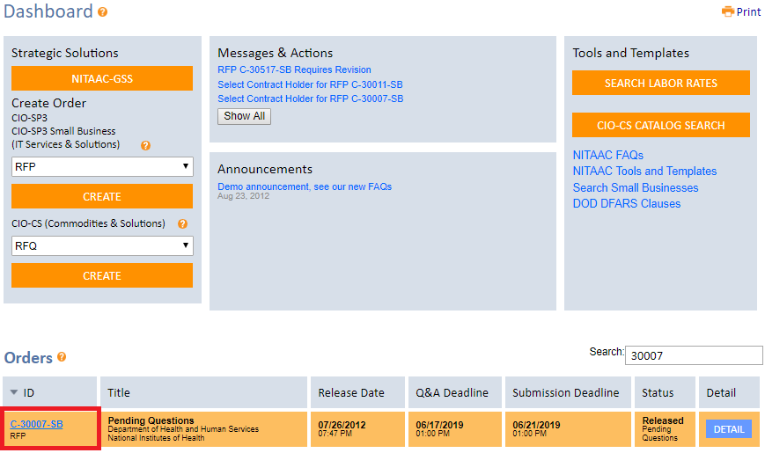

- Click the “Compete” tab.

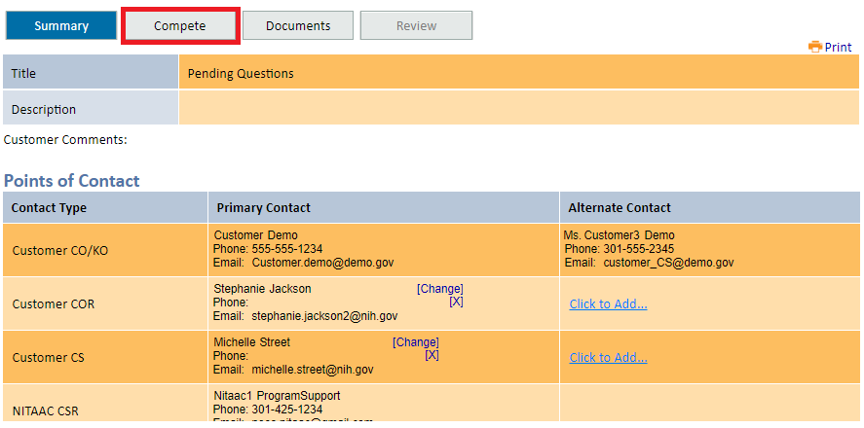

- Select the Q&A subtab to see a list of submitted questions. To respond simply:
  - Type the response in the “Answer” field
  - Ensure the check box in the “Release” column is checked
  - Click the “Save and Release” button

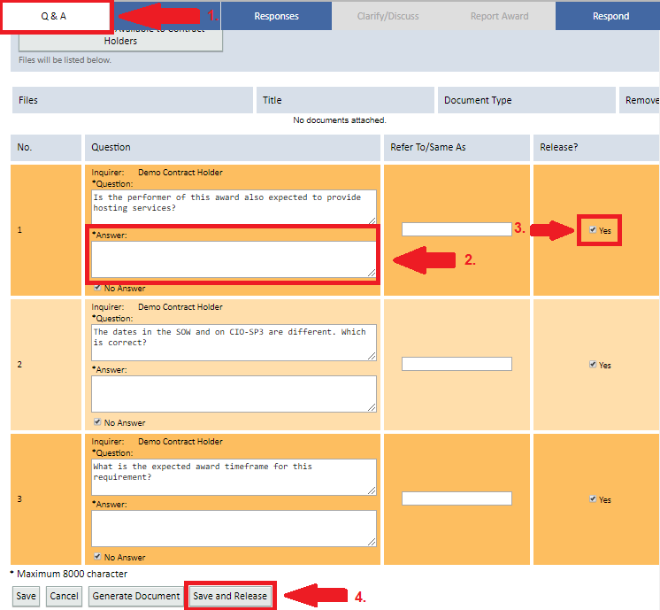

- Alternatively, you are also able to respond to all questions at once using the generate document feature. To do this, click the “Generate Document” button at the bottom of the screen.

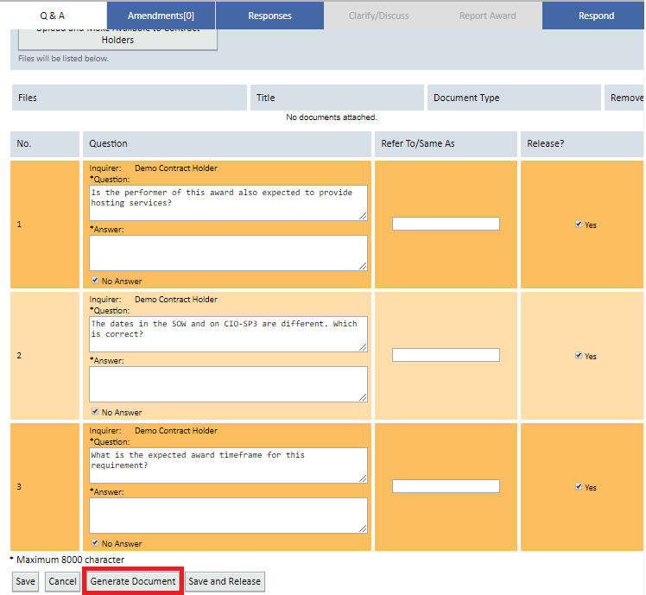

- This will generate a word document that lists all the previously submitted questions but omits the contract holder information.

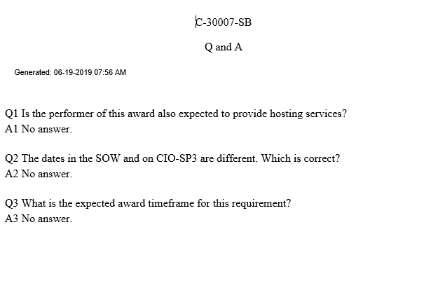

- Once the questions have been answered, return to the Q&A subtab and upload the Q&A document, then click the “Save and Release” button at the bottom of the page.

