e-GOS Task Order Request Guide

The e-GOS system allows agencies to issue, compete and award task orders under CIO-SP3 and CIO-SP3 Small Business. Follow these simple steps to issue, compete and award task orders.

  - In your web browser, go to https://cio.egos.nih.gov/#login and enter your username and password.
  - Select RFP from the drop-down menu and click “Create.”
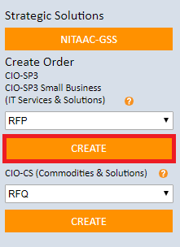

  - Enter a title and description for your requirement. Next, add points of contact by clicking “Click to Add. “

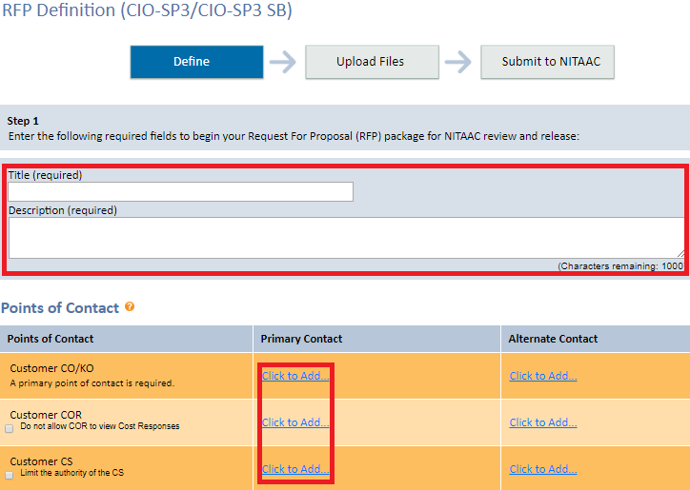
  - Select all contract types that apply from the list.
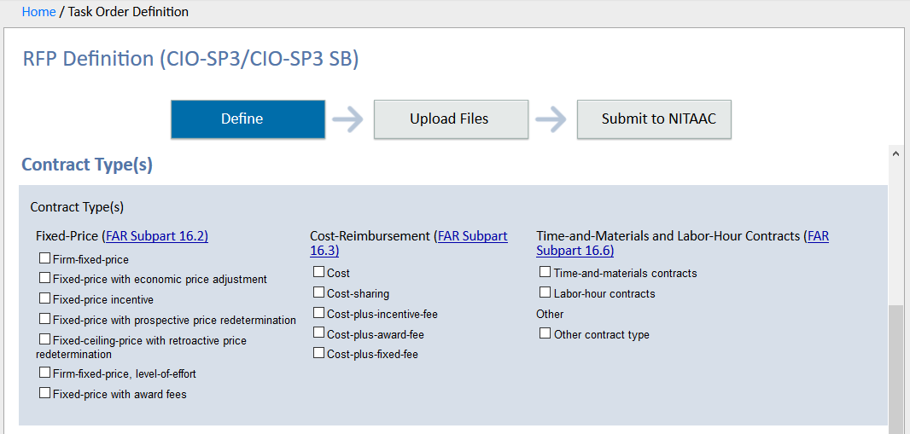

  - Choose a GWAC and set-aside category from the dropdowns and select all required task areas.
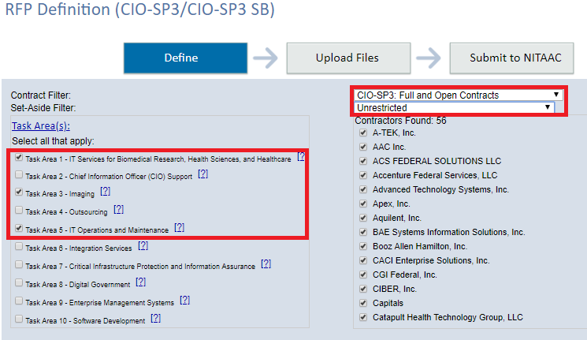

  - If you uncheck one or more contractors from the list, you will be asked to select an exception to fair opportunity from the dropdown.
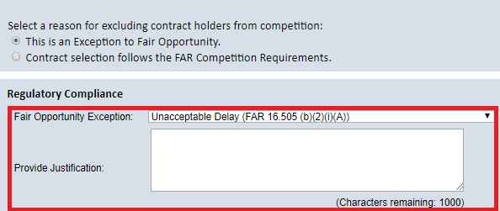

  - If your RFP is performance-based check “Yes.” Otherwise, the system defaults to “No.”

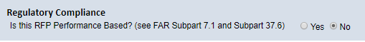

  - Email notifications are sent to unsuccessful offerors by default. If you do not wish for this notice to be sent, uncheck the “Unsuccessful Offerors” box.

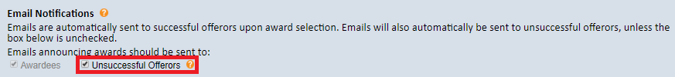

  - Enter your independent government cost estimate.
Note: This is for NITAAC use only. Contractors do not see this field.

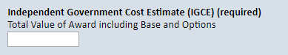

  - Choose when you would like the order to be released and whether or not you will accept questions. If you choose to accept questions, next, choose the date and time for questions and proposals to be submitted and enter the anticipated award date.
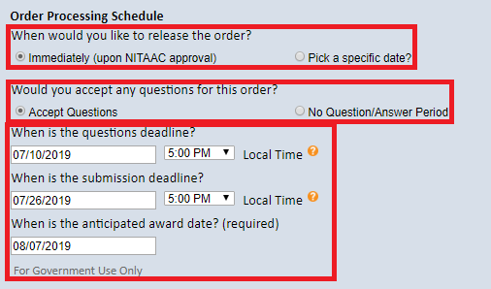

  - Click the “Upload Files” tab. Select the document type from the dropdown, enter a document title, choose the file from your computer, then click “Add Document.”

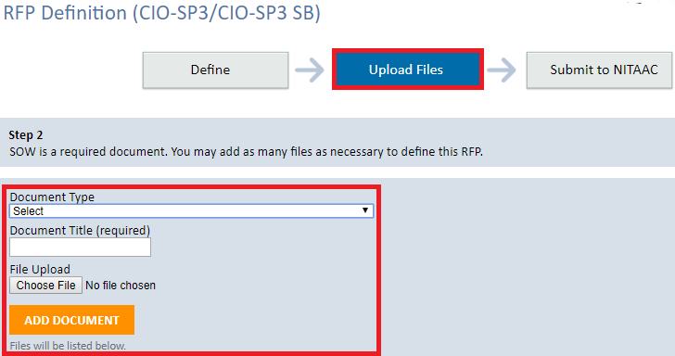

  - Click the “Submit to NITAAC” tab then click the “Submit to NITAAC” button at the bottom of the screen.

