e-GOS Delivery Order Request Guide

The e-GOS system allows agencies to issue, compete and award delivery orders under CIO-CS. To easily issue, compete and award delivery orders, follow these simple steps:

  - In your web browser, go to https://cio.egos.nih.gov/#login and enter your username and password.
  - Select RFQ from the drop-down menu and click “Create.”
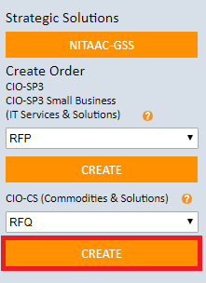

  - Enter a title and description for your requirement. Next, add points of contact by clicking “Click to Add.”

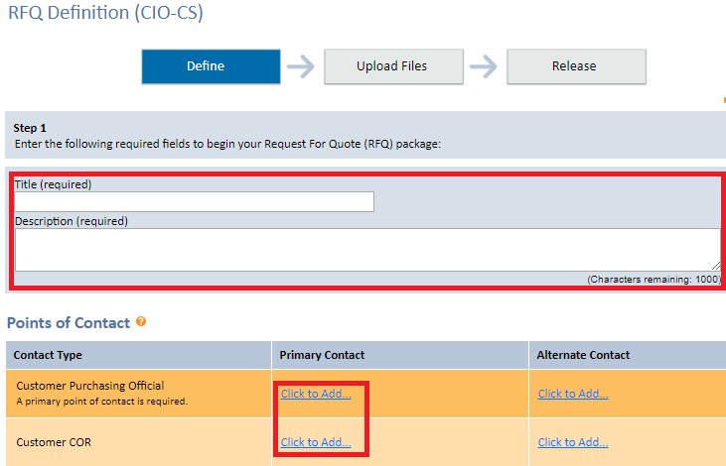

  - Choose the type of contract holder to send the requirement to. Select whether or not to set the requirement aside for small businesses.
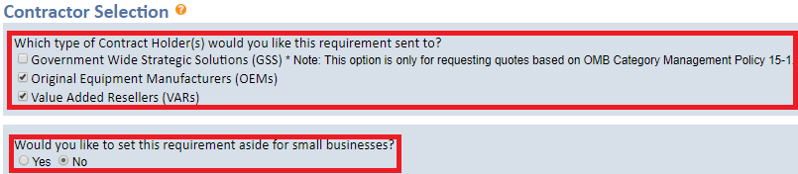

  - Select a small business set-aside category, if applicable.
  - If you uncheck one or more contractors from the list, you will be asked to select an exception to fair opportunity from the dropdown.
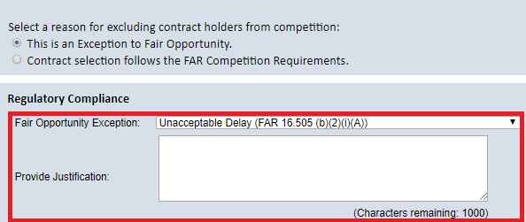
  - Indicate whether a brand name justification will be used.
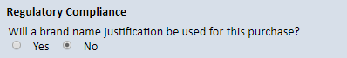
  - Enter the delivery schedule or period of performance.

  - Email notifications are sent to unsuccessful offerors by default. If you do not wish for this notice to be sent, uncheck the “Unsuccessful Offerors” box.
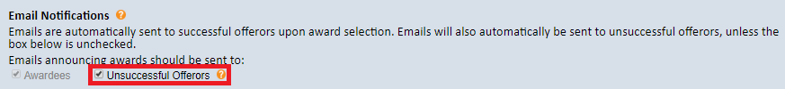

  - Enter your independent government cost estimate.
Note: This is for NITAAC use only. Contractors do not see this field.

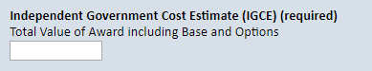

  - Enter shipping information.
Note: If multiple shipments are required, check the “See Attached Shipping Information” box.

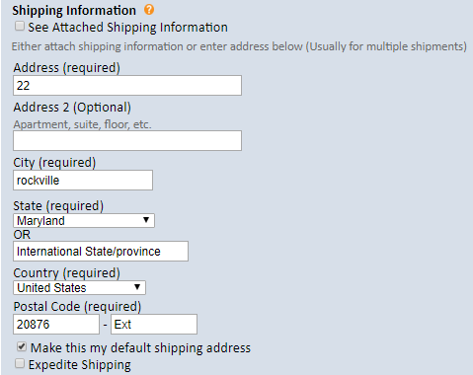

  - Choose when you would like the order to be released and whether or not to accept questions. Next, choose the date and time for questions and proposals to be submitted. Enter the anticipated award date.
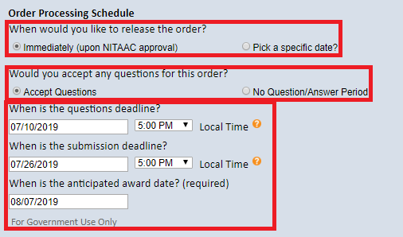
  - Click the “Upload Files” tab. Select the document type from the dropdown, enter a document title, choose the file from your computer, then click “Add Document.”
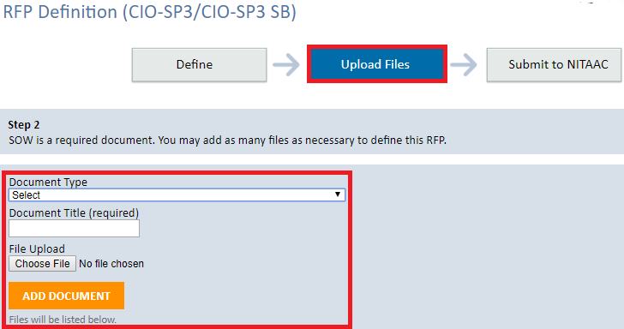

  - Click the “Release” tab then click the “Release” button at the bottom of the screen.
