e-GOS Request for Information Guide

The e-GOS system allows agencies to conduct market research by issuing requests for information under CIO-SP3 and CIO-SP3 Small Business. To begin the market research process:

  - In your web browser, go to https://cio.egos.nih.gov/#login and enter your username and password.
  - Select RFI from the drop-down menu and click “Create.”
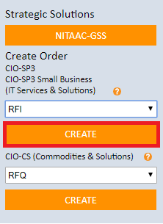
  - Enter a title and description for the RFI. Next, add points of contact by clicking “Click to Add.”
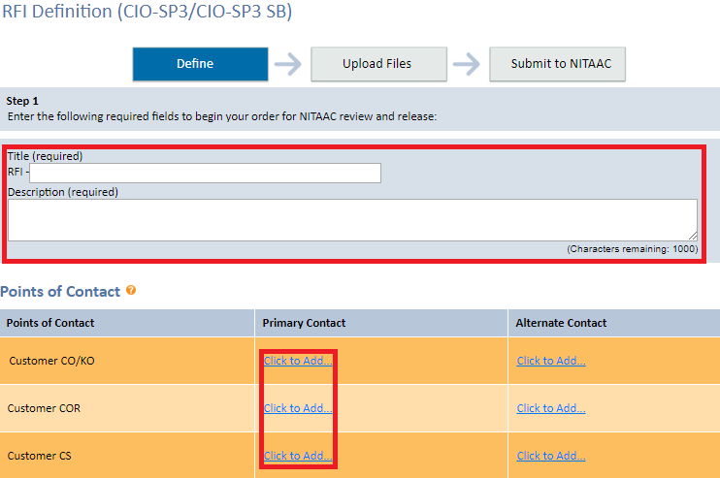
  - Choose a GWAC and set-aside category from the dropdowns and select all required task areas.
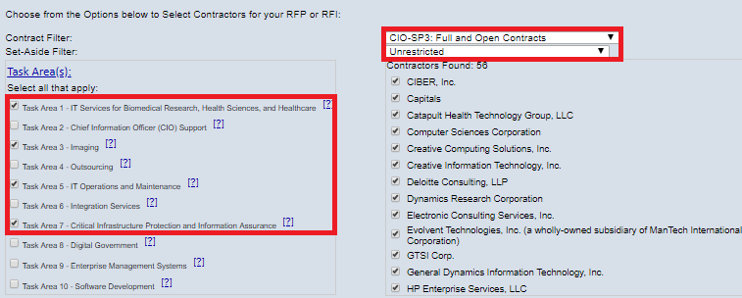

  - Choose when you want the RFI to be released and whether or not you will accept questions. Next, choose the date and time for questions and responses to be submitted.
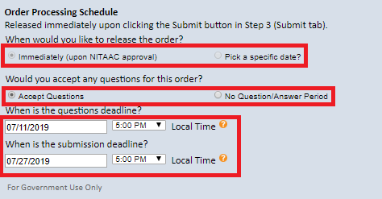

  - Click the “Upload Files” tab. Select the document type from the dropdown, enter a document title, choose the file from your computer, then click “Add Document.”
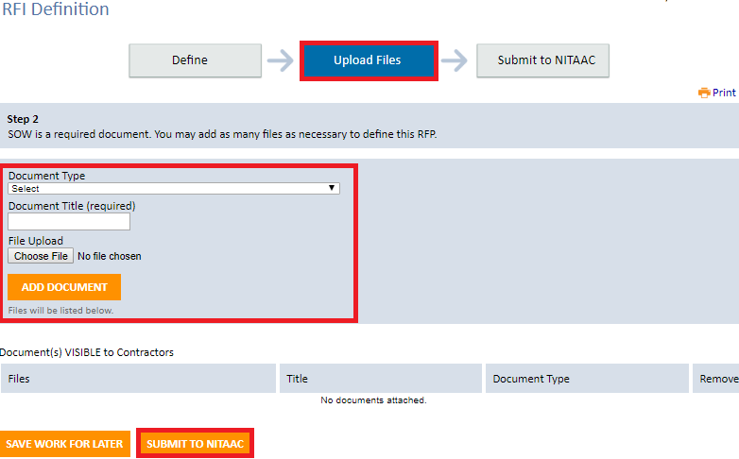

  - Click the “Submit to NITAAC” tab then click the “Submit to NITAAC” button at the bottom of the screen.

