Workforce Planning & Analytics: Linking HR, Cost, and Performance Data in Decision-making
Federal agencies today are operating in some of the most challenging financial climates in decades, with ever expanding expectations around accountability and performance. Many agencies struggle to balance the need for immediate action with taking a more long-term strategic approach, which include a changing workforce, new technologies, lack of workforce engagement, labor cost, and digital disruption.
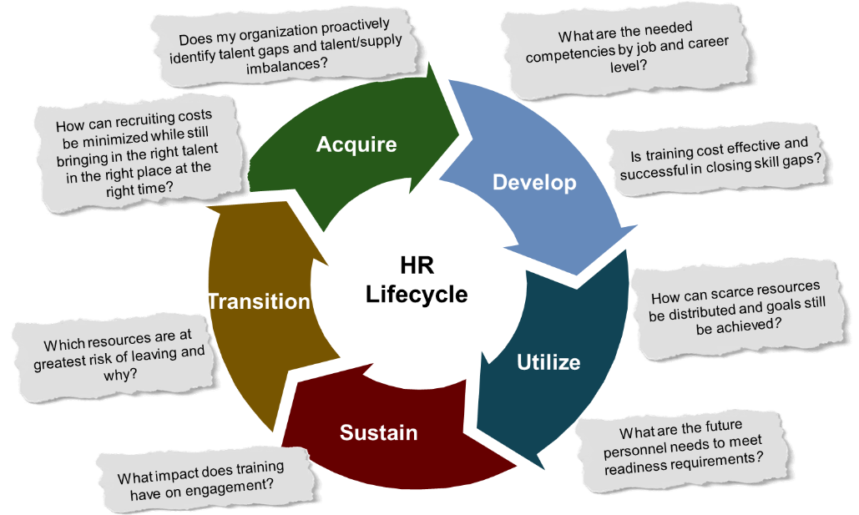
One answer to these challenges lies in utilizing data and analytics, which can lead to improved efficiencies and increased savings. By identifying and analyzing the right data, federal leaders can move beyond reactionary tactics and adopt a proactive approach to workforce planning while controlling costs and charting an achievable path toward long-term fiscal health, employee performance and retention, and attaining mission goals.
The National Academy of Public Administration (NAPA) stated that information linking budget, costs, and performance to support resource allocation decisions is one of the most needed types of analysis. Collecting more data points makes it easier to discern trends, patterns, opportunities and competitive advantage. Today the federal government no longer suffers from a lack of data, however selecting the right data can be difficult. When sifting through mountains of data, an agency’s goals should form a question, and then seek the data that will answer it. The resulting insights can help the agency achieve its goals.
Information linking budget, costs, and performance to support resource allocation decisions is one of the most needed types of analysis.
NAPA, Financial and Related Information for Decision-Making
Agencies have implemented a variety of solutions with wide ranging outcomes, but one of the most successful undertakings was achieved by a multi-billion-dollar service agency with over 2,000 offices across the country and approximately 70 percent of their budget in staffing. Their leadership understood that implementing ‘across the board’ cuts to programs and internal departments would significantly impact their ability to perform and disproportionally burden their services for the public. They decided that operational changes needed an analytically-based solution utilizing a data driven approach. Their approach, depicted in Figure 1.0 below, was to develop an assessment of the current state of their workforce, understand and develop future demand for programs, and develop a roadmap that accounted for this gap.
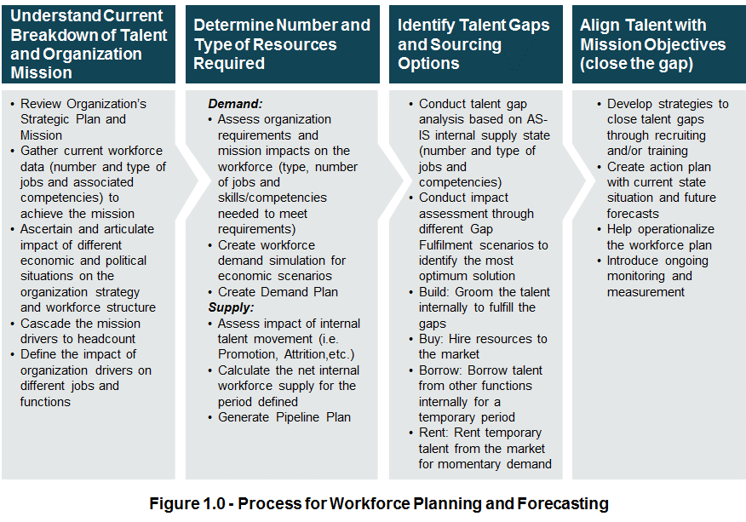
They accepted that each office and state across the country deals with a unique combination of programs and challenges that would not allow staffing to be based solely on public demand for programs. They faced a complex organizational problem which would require an approach that captures their complexity and reduces it to understandable components and includes the factors and variables that speak to overall resource effectiveness. By combining forecasted workload volumes with performance expectations that are considered accurate and credible with the workforce and supervisors, and integrating specific location characteristics and budget factors, they can develop a data-driven workforce forecast by job type under a constrained budget.
Data-driven decision making does not need to be overly complicated and this agency was able to leverage data they had already collected to begin the process and build buy-in from within by during subsequent workshop. Transparency in the development of an analytical solution reduces potential pushback prior to implementation. By focusing team efforts on creating value from existing data to improving resource distribution, agency leadership can optimize entire sectors of the workforce and in the process, drive sustainable hard dollar cost savings and productivity improvements.
From an operational perspective, this approach provides agency leadership, specifically the chief human capital officers (CHCOs), with a defensible approach to unlocking the value of their workforce data by transforming it into actionable workforce metrics and analytics—intelligence that you can use to drive informed decision-making regarding workforce gaps, surpluses, risks, challenges, and costs. Agencies need to look beyond traditional reactionary tactics and adopt a holistic, comprehensively forecast your future talent needs and challenges with a high degree of accuracy and make more informed, proactive workforce decisions. Analytically-based decision-making is an invaluable and cost-effective tool for organizations especially during difficult financial periods and increased public scrutiny.
For more information on how implementing Human Capital Analytics can help your agency contact:
Kristen Vaughan  kristen.o.vaughan@accenturefederal.com | Kris Naleszkiewicz  k.naleszkiewicz@accenturefederal.com

